

Semester One Examination, 2020

Question/Answer booklet

MATHEMATICS

SOLUTIONS
APPLICATIONS
UNIT 3

Section One:

Calculator-free

WA student number: In figures

In words

Your name

Number of additional
answer booklets used
(if applicable):

Time allowed for this section
Reading time before commencing work: five minutes
Working time: fifty minutes

Materials required/recommended for this section
To be provided by the supervisor
This Question/Answer booklet
Formula sheet

To be provided by the candidate
Standard items: pens (blue/black preferred), pencils (including coloured), sharpener,
correction fluid/tape, eraser, ruler, highlighters

Special items: nil

Important note to candidates
No other items may be taken into the examination room. It is your responsibility to ensure that you do not have any unauthorised material. If you have any unauthorised material with you, hand it to the supervisor before reading any further.

Structure of this paper

Section | Number of  questions  available | Number of  questions to  be answered | Working  time  (minutes) | Marks  available | Percentage  of  examination
Section One:  Calculator-free | 8 | 8 | 50 | 52 | 35
Section Two:  Calculator-assumed | 13 | 13 | 100 | 98 | 65
 |  |  |  | Total | 100

Instructions to candidates

1. The rules for the conduct of examinations are detailed in the school handbook. Sitting this examination implies that you agree to abide by these rules.

2. Write your answers in this Question/Answer booklet preferably using a blue/black pen.
Do not use erasable or gel pens.

3. You must be careful to confine your answers to the specific question asked and to follow any instructions that are specific to a particular question.

4. Show all your working clearly. Your working should be in sufficient detail to allow your answers to be checked readily and for marks to be awarded for reasoning. Incorrect answers given without supporting reasoning cannot be allocated any marks. For any question or part question worth more than two marks, valid working or justification is required to receive full marks. If you repeat any question, ensure that you cancel the answer you do not wish to have marked.

5. It is recommended that you do not use pencil, except in diagrams.

6. Supplementary pages for planning/continuing your answers to questions are provided at the end of this Question/Answer booklet. If you use these pages to continue an answer, indicate at the original answer where the answer is continued, i.e. give the page number.

7. The Formula sheet is not to be handed in with your Question/Answer booklet.
Section One: Calculator-free 35% (52 Marks)
This section has eight questions. Answer all questions. Write your answers in the spaces provided.

Working time: 50 minutes.

Question 1 (6 marks)
Consider the following graph $G$.
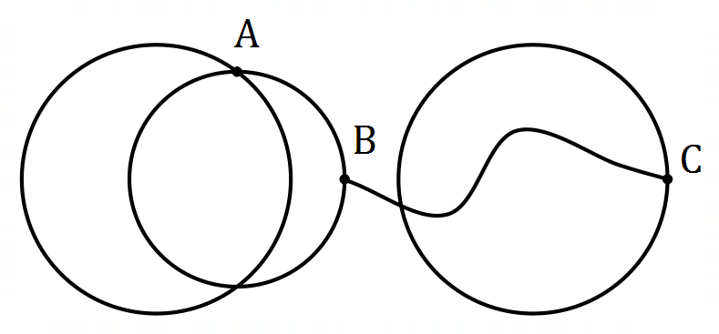

(a) Draw $G$ in the plane, to clearly show that it is planar. (2 marks)
Solution
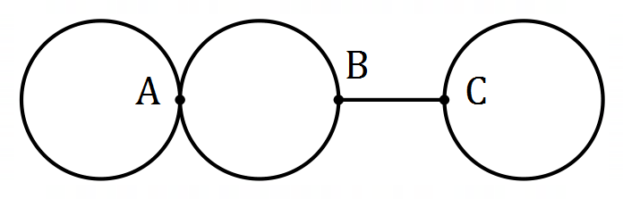
Specific behaviours
5 edges, 3 labelled vertices
ü correctly drawn in the plane

(b) State the degree of each vertex and the degree sum for $G$. (2 marks)
Solution
$$d_{A}=4, d_{B}=3, d_{C}=3$$

$$d_{A}+d_{B}+d_{C}=10$$

Specific behaviours
correct degrees
ü correct degree sum

(c) Explain how to recognise a bridge in a connected graph and state, with justification, whether $G$ contains a bridge. (2 marks)
Solution
When a bridge is removed from a connected graph, the graph becomes disconnected.

Yes, edge $BC$ is a bridge in $G$.

Specific behaviours
correct explanation
ü identifies edge that is bridge

Question 2 (6 marks)
A recursive rule for a sequence is $T_{n+1}=T_{n}-2.5, T_{3}=11.5$.

(a) Briefly explain which feature of the recursive rule indicates that the sequence is arithmetic.
(1 mark)
Solution
There is a constant difference of $-2.5$ between consecutive terms.

Specific behaviours
indicates the constant difference

(b) Determine $T_{4}$ and $T_{1}$. (2 marks)
Solution
$$T_{4}=11.5-2.5=9$$

$$T_{1}=11.5+2.5+2.5=16.5$$

Specific behaviours
value of $T_{4}$
ü value of $T_{1}$

(c) Graph the first six terms of the sequence on the axes below. (2 marks)
Solution
See graph
Specific behaviours
at least $4$ correct points
ü all correct, no line

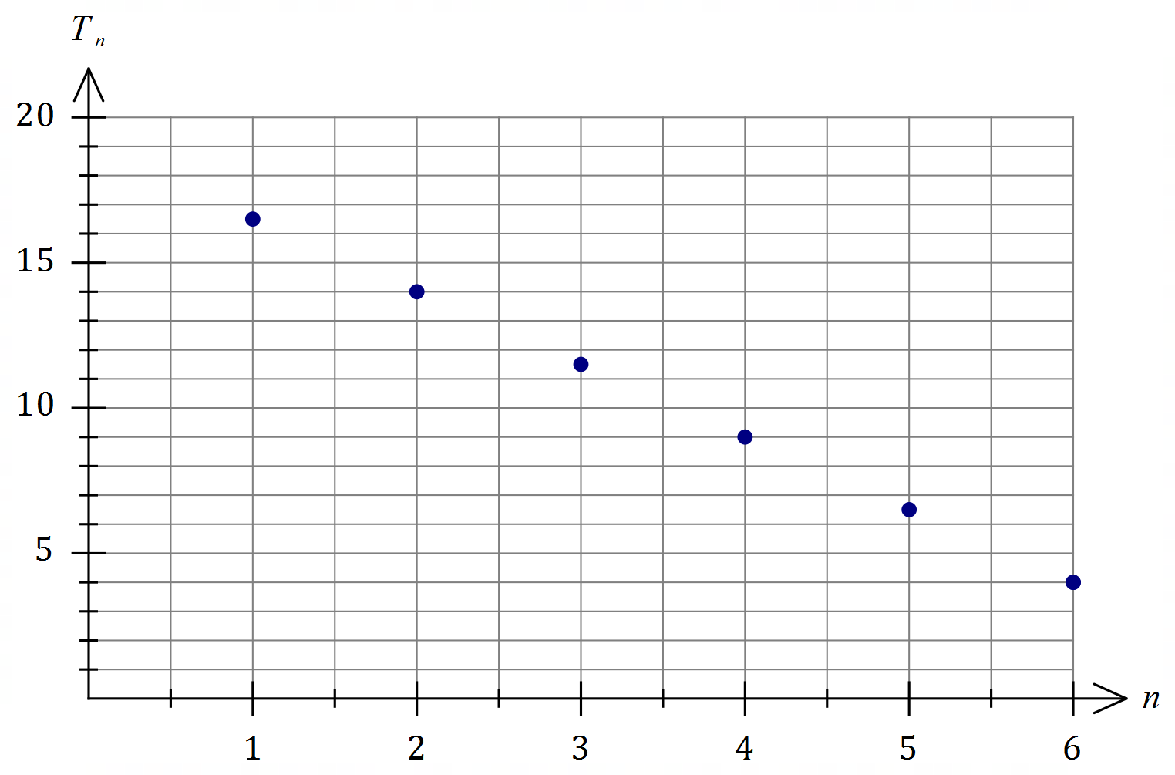

(d) What feature of the graph indicates that the sequence is arithmetic? (1 mark)
Solution
The points are linear / lie in a straight line.

Specific behaviours
indicates linear nature

Question 3 (6 marks)
(a) Connected planar graph $G_{1}$ has $2$ vertices and $5$ edges.

(i) Use Euler's formula to determine the number of faces in $G_{1}$. (2 marks)
Solution
$$2+f-5=2$$
$$f=5$$

Specific behaviours
correct use of Euler's formula
ü correct number of faces

(ii) Sketch a possible graph $G_{1}$. (2 marks)
Solution
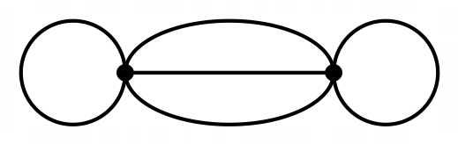(Example only - others exist)
Specific behaviours
correct number of edges and vertices
ü connected, with correct number of faces

(b) Graph $G_{2}$ has $4$ vertices and is Eulerian. The length of the Eulerian trail is $6$. Sketch a possible graph $G_{2}$. (2 marks)
Markers note
Penalise $1$ mark overall if vertices not clearly identified.
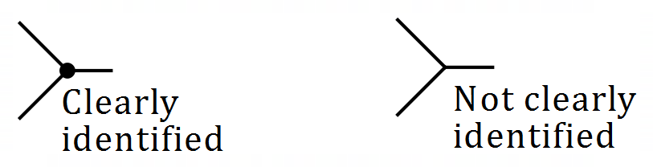

Solution
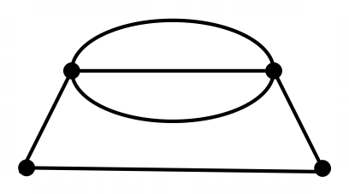(Example only - others exist)
Specific behaviours
connected with $6$ edges and $4$ vertices
ü all vertices with even degree

Question 4 (7 marks)
A recent survey asked people their age and the question "How often do you feel lonely?". The responses for the age groups $16\text{-}24$ years and $65\text{-}74$ years are shown below. The categories in the key are shown from left to right in the stacked percentage frequency graph.

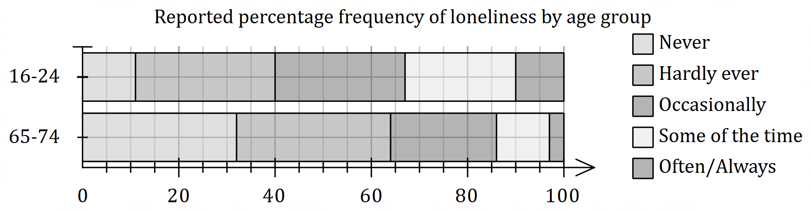

(a) State the second largest category for the $16\text{-}24$ age group. (1 mark)
Solution
'Occasionally'.
Specific behaviours
correct category

(b) State the percentage of those

(i) in the $16\text{-}24$ age group who responded with 'Some of the time'. (1 mark)
Solution
$$23\%$$
Specific behaviours
correct percentage

(ii) in the $65\text{-7}4$ age group who responded with 'Hardly ever' or 'Occasionally'. (1 mark)
Solution
$$100-32-14=54\%$$
Specific behaviours
correct percentage

(c) Use the graph to explain why the data suggests an association exists between feeling lonely and age. (2 marks)
Solution
Only $11\%$ of $16\text{-}24$ age group never feel lonely compared to $32\%$ of the $65\text{-}74$ age group. The difference in these percentages suggests an association.

Specific behaviours
example using correct percentages
ü indicates different percentages suggest association

(d) Briefly discuss non-causal explanations for the observed association. (2 marks)
Solution
The association may be due to coincidence (possibly only a small, biased survey, etc) or due to confounding by another variable (possible that one age group lived in city and the other in rural area, etc).

Specific behaviours
indicates coincidence
ü indicates confounding

Question 5 (6 marks)

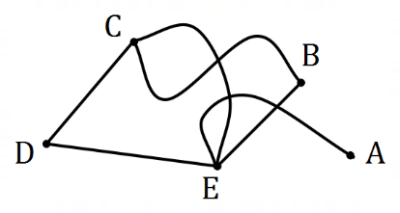

Graph $G$ is shown. $G_{1}$ and $G_{2}$ are subgraphs of $G$, so that each subgraph has $5$ vertices but one less edge than $G$.

(a) $G_{1}$ does not satisfy Euler's formula. State which edge must be removed from $G$, and show that $G_{1}$ does not satisfy Euler's formula. (3 marks)
Solution
Remove edge $AE$.

Substituting the values $V=5, F=3, E=5$ into the expression $V+F-E$ then $5+3-5=3$ but Euler's formula states this value must equal $2$. Hence graph does not satisfy Euler's formula.

Specific behaviours
correct edge to remove
correct values of $V, F, E$
ü substitutes and shows formula not satisfied

(b) $G_{2}$ is bipartite. State which edge must be removed from $G$, and draw $G_{2}$ to clearly show the partite sets. (3 marks)
Solution
Remove edge $CE$.
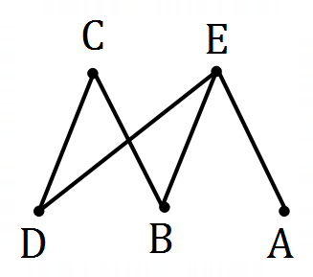
(Bipartite graphs have no odd length cycles)
Specific behaviours
correct edge to remove
ü correctly shows partite sets
ü correctly draws edges

Question 6 (7 marks)
The scatterplot below shows the number of PC's per $100$ people on the $x$-axis and the
unemployment rate, as a percentage, on the $y$-axis for a selection of countries in $2016$.

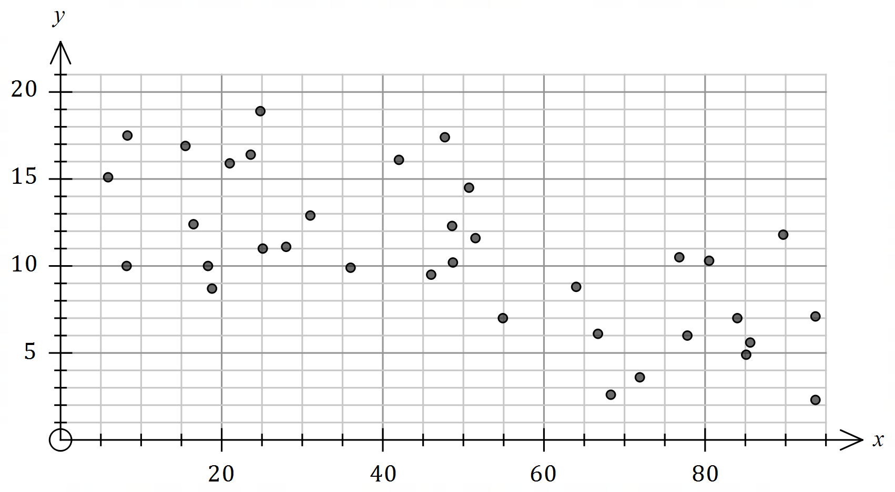

(a) Describe the strength and direction of the association between the variables. (2 marks)
Solution
The association is of moderate strength and in a negative direction.

Specific behaviours
strength
ü direction

(b) The equation of the least-squares line for the data is $y=15.8-0.11x$. Interpret the intercept and the slope of this line. (3 marks)
Solution
The intercept means that if a country had no PC's then the unemployment rate is expected to be $15.8\%$.
The slope means that for every extra PC per $100$ people, the unemployment rate is expected to fall by $0.11\%$.

Specific behaviours
interprets intercept
ü interprets slope
ü includes units (%) in interpretations

(c) A newspaper article used the graph to claim that increasing the number of PC's per person in a country caused the unemployment rate to fall. Comment on this claim.
(2 marks)
Solution
The claim is unlikely to be true - an observed association does not necessarily mean there is a causal relationship between variables.

Specific behaviours
disputes validity of claim
ü comments on causation

Question 7 (7 marks)
In a set of $5$ pages on a website, there are hyperlinks from page $1$ to page $2$, from page $2$ to
page $5$, from page $3$ to page $1$, from page $4$ to pages $2$ and $3$, and from page $5$ to page $4$.

(a) Construct digraph $D$ to show the above information, where pages are represented by vertices and links by directed edges. (2 marks)
Solution
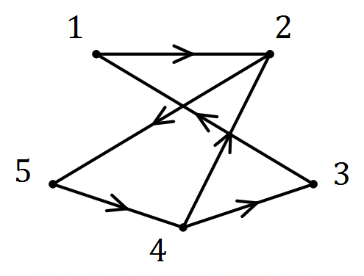

Specific behaviours
vertices all have correct degree
ü edges all directed correctly

(b) Construct an adjacency matrix for $D$. (2 marks)
Solution
$$\begin{matrix} & \begin{matrix}1 & 2 & 3 & 4 & 5\end{matrix} \\ \begin{matrix}1 \\ 2 \\ 3 \\ 4 \\ 5\end{matrix} & \left[\begin{matrix}0 & 1 & 0 & 0 & 0 \\ 0 & 0 & 0 & 0 & 1 \\ 1 & 0 & 0 & 0 & 0 \\ 0 & 1 & 1 & 0 & 0 \\ 0 & 0 & 0 & 1 & 0\end{matrix}\right]\end{matrix}$$

Specific behaviours
at least $4$ correct rows
ü all correct

(c) List, starting at page $5$ and in the order visited, vertices in $D$ that form a
Solution
$$\left\{5, 4, 2\right\}\text{ or} \left\{5, 4, 3\right\}$$

Specific behaviours
correct walk

(i) walk of length $2$. (1 mark)

Solution
$$\left\{5, 4, 2, 5\right\}$$

Specific behaviours
correct cycle

(ii) cycle of length $3$. (1 mark)

(iii) trail of length $4$. (1 mark)
Solution
$$\left\{5, 4, 3, 1, 2\right\}$$

Specific behaviours
correct trail

Question 8 (7 marks)
Every day, $10\%$ of the water in a tank is drained for crop irrigation and then the tank is topped up with $40$ kL of water. The tank has a maximum capacity of $350$ kL.

At the start of Day $1$, before water is drained for the crops, the tank contains $50$ kL.

(a) Determine the amount of water in the tank at the start of Day $2$. (2 marks)
Solution
$$10\%×50=5$$

$$50-5+40=85 \text{kL}$$

Specific behaviours
amount drained
ü correct amount

(b) Determine a recursive rule for the amount of water, $A_{n}$, in the tank at the start of Day $n$.
(2 marks)
Solution
$$A_{n+1}=0.9A_{n}+40, A_{1}=50$$

Specific behaviours
correct multiplier
ü correct addition and first term

(c) Explain why the tank will never empty. (1 mark)
Solution
With this type of recursive rule, the amount in the tank will always increase, tending towards a steady state amount. OR
Amount drained is always less than amount added.

Specific behaviours
indicates amount always increasing

(d) State, with justification, whether the tank will overflow. (2 marks)
Solution
Let $x$ be long-term steady state.
$$x=0.9x+40 \\ 0.1x=40 \\ x=400$$
Hence tank will overflow, as the capacity of the tank ($350$ kL) is less than the long-term steady state ($400$ kL).

Specific behaviours
indicates correct long-term steady state
ü states tank will overflow, with justification

Supplementary page

Question number: _________

© 2020 WA Exam Papers. Kennedy Baptist College has a non-exclusive licence to copy and communicate this document for non-commercial, educational use within the school. No other copying, communication or use is permitted without the express written permission of WA Exam Papers. SN245-156-3.

